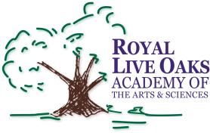 1398 Church Road, Hardeeville, SC 29927 • 843-784-2630 • www.rloacs.org

AGENDA

The Royal Live Oaks Academy of Arts & Sciences Charter School Board Meeting
November 19, 2013 6:00pm
Administration Building

- Executive Session

- Old business:

  - Minutes of October 15, 2013 meeting - Secretary

- New business:

  - RLOA Mission Statement - Chair
  - Finance Report and 2013-14 Budget - Bill Moser, Kelly-Moser Consulting
  - Audit Report - Michelle Jones, Elliott-Davis LLC
  - Update on Building, Finance, and Architectural Work – Facilities Management
  - Land Proposal - Facilities Management
  - Board Elections: Counting of Votes
  - Board Self-Evaluation - Secretary
  - SC Annual School Report Card - Executive Director
  - School Updates – Executive Director
  - Other

- Public Comment

